Project Title: Agentic Farmer Query Assistant (AgriAssist)
Problem: Farmers in India frequently face urgent queries related to crop diseases, pest outbreaks, fertilizer usage, mandi prices, and government schemes. The primary existing support — Kisan Call Centre (KCC) — is human-staffed, operates limited hours, handles one call at a time, and is unavailable 24/7. This creates a critical information gap that directly affects crop yield and farmer income.

Proposed Solution: An AI system that accepts farmer queries via text, voice, or leaf image in Hindi/Punjabi/English, classifies intent, retrieves information from the most relevant source, and generates a clear actionable answer in the farmer's language — available 24/7 at no cost.

End Users: Indian farmers, primarily in Punjab, Haryana, and UP — accessed via a simple browser-based web app, no installation required.

Pipeline:
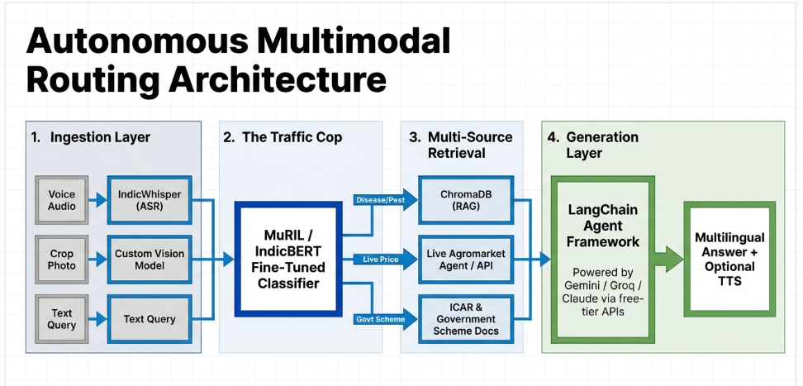
Farmer query (text/voice) + optional leaf image
↓
[If voice] IndicWhisper ASR → text
[If image] Fine-tuned EfficientNet-B0 → disease label + confidence
↓
Query Classifier (fine-tuned MuRIL/IndicBERT)
→ disease / pest / weather / price / scheme / general
→ CV output passed as context if image uploaded
↓
LangChain Agent routes to:
- KCC RAG via ChromaDB (disease/pest queries)
- Live Agmarknet API (price queries)
- ICAR/scheme docs RAG (government scheme queries)
↓
LLM (Gemini/Groq free tier) generates plain-language answer
↓
[Optional] Sarvam TTS speaks answer back in farmer's language

Datasets:
Dataset | Purpose | Source
KCC Query Dataset | RAG knowledge base + classifier training | data.gov.in (public)
PlantVillage | EfficientNet fine-tuning (crop disease CV) | Kaggle (public)
ICAR/myscheme.gov.in docs | RAG for scheme/advisory queries | Public government portals
Agmarknet API | Live mandi price retrieval | agmarknet.gov.in (free API)

Models:
Model | Role | Trained by team?
EfficientNet-B0/Other vision model | Crop disease detection from leaf image | Fine-tuned on PlantVillage
MuRIL / IndicBERT | Query intent classification | Fine-tuned on KCC data
IndicWhisper | Speech-to-text (Hindi/Punjabi) | Pretrained, inference only
ChromaDB + multilingual sentence transformer | RAG retrieval | Vector DB, no training
Gemini / Gpt API | Final answer generation | API call, free tier
Sarvam TTS | Spoken response in regional language | API call

Tech Stack: LangChain · ChromaDB · IndicWhisper · EfficientNet-B0/other vision model · MuRIL/IndicBERT · Gemini/Gpt API · Sarvam TTS · Gradio · HuggingFace Spaces

